**Community Engagement Lead**

Application Deadline: 9am on Monday 12th May 2025

**Job Pack**

**Welcome from our CEO**

**Thank you for your interest in this role of at Disability Rights UK.**

Having entered our second decade, this is an exciting time to join DR UK. We are a Disabled People’s Organisation (DPO), which is an organisation for Disabled people that is led and controlled by Disabled people where at least 75% of the board and 50% of staff identify as Disabled. We actively demonstrate our commitment to the Social Model of Disability through our work and hiring practices.

We are part of a UK wide movement of Disabled people led organisations and Disabled people campaigning for equity, equality and inclusion to be embedded in everyday life. We have built key partnerships with allies and funders and have an effective working relationship with government departments and policy makers.

The last few years have been very difficult for Disabled people and their organisations – during the pandemic our hard-won rights were challenged, and Disabled people are being disproportionately affected by the cost-of-living crisis. We were never more needed than now.

Within this document you will find background information about the organisation, job description, person specification and information about how to apply. If you would like a chat about the vacancy, or have any questions, please contact us at [recruitment@disabilityrightsuk.org](mailto:recruitment@disabilityrightsuk.org)

**Kamran Mallick**

**CEO of Disability Rights UK**

**About Us**

We had 10,000 contacts with individuals through events and our independent living advice line, student and members helpline and information line.

In 2020, as we went into lockdown and closed the office, we set up a weekly meeting of CEOs and Policy staff from Disabled People’s Organisations. The group, Our Voices continues to meet, sharing knowledge, speaking with a unified voice on the inequalities that continued through the pandemic.

Our Disability Rights Handbook continues to be a vital support for Disabled people. Written by benefits specialists, this guide to benefits is now published online and in print.

We work in partnership with funders to test ways to break down systemic barriers faced by Disabled

**We are Disabled people leading change**

Disability Rights UK is the leading charity of its kind in the UK. We are run by and for people with lived experience of disability or health conditions.

We are committed to the Social Model of Disability and led by people with lived experience of disability or long-term health conditions. 85% of our trustees have personal experience.

DR UK is a member-led charity, with disabled people and organisations led by disabled people having the controlling vote.

We are committed to working with and for people with all types of impairment and health conditions.

**Last year we reached more than 1.2 million people with information developed by and for disabled people**

Our free factsheets attracted 1.8 million downloads and over 90% of users said our factsheets were useful to their purposes.

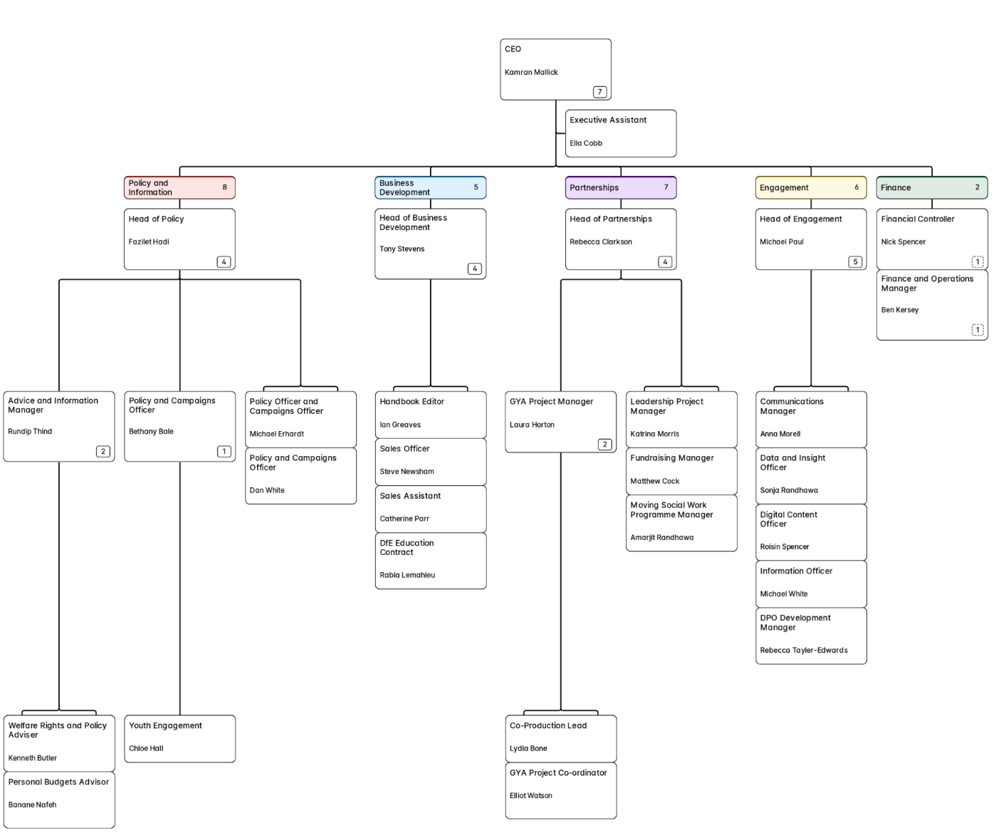

**Our Structure**

**The Role**

**Community Engagement Lead**

**Salary: £37,292 per annum**

**Hours:** 35 hours per week, Monday to Friday

**Office Base:** Disability Rights UK office (London E20), flexible working policy in place

**Status:** Three years fixed term, with a view to being made permanent

**Line manager:** Head of Engagement

Disability Rights UK is part of a partnership that has received £1.5 million from [The National Lottery Community Fund](https://www.tnlcommunityfund.org.uk/) to deliver an ambitious and innovative new programme that will support charities in England and Scotland to empower diverse and marginalised communities to respond to climate change and to get their voices heard in environmental policy and media debates.

The programme will focus on Disabled people, those facing financial insecurity, and people from ethnic minority communities. These voices are often the least heard from in national and local debates on our environment. This new work aims to change that.

The Community Engagement Lead will deliver activity with smaller charities and grassroots organisations supporting Disabled people that:

* Increases awareness of the impact of environmental change and related policy on different communities
* Listens to people in these communities to find out what actions they want charities and local government to take
* Develops shared local environmental policy priorities and empowers these organisations to advocate directly to local and national policy makers
* Identifies actions that these organisations can take to support communities to respond to climate change, and helps organisations to implement them
* Identifies people with lived experience to receive hands on training in order to act as diverse champions to media and policy makers
* They will work closely with other Community Engagement staff employed by Turn2Us &The Race Equality Foundation, focused on reaching organisations supporting those facing financial insecurity and people from ethnic minority communities.

**Purpose of job:**

To manage our relationships with smaller charities, grassroots organisations and people with lived experience in relation to the environmental crises, working closely with other partners on the project to empower communities to respond to climate change and to get diverse voices heard in environmental debates.

**Main duties:**

**Partnership working**

* Maintain effective and productive relationships and ‘ways of working’ with the other programme partners
* Have regular contact with the Programme Manager at NPC to ensure they are kept up-to-date and can input as appropriate.
* Regularly communicate with wider programme partners and ensure that information, intelligence on programme delivery and best practice is shared

**Programme design**

* Facilitate the design of programme activity each year with input from programme partners, grassroots organisations and people with lived experience of disability

**Programme delivery**

* Develop and deliver training and practical workshops to help community groups and charities support the people they serve to respond to environmental change
* Develop and deliver deliberation groups with people with lived experience to understand their priorities for environmental action by charities, community groups and policy makers
* Support joint advocacy activity, including through input on joint position statements, identifying key policy targets, and developing briefings that supports influencing by programme participants
* Support environmental action, including through developing tools, research and resources
* Identify and build relationships with Disabled people, to receive training and opportunities to act as a spokesperson on environmental change in the media and with policy makers

**Communications and sharing learning**

* Act as a contact point for the communications team on the programme, providing content for articles, reports and other communications materials.
* Facilitate shared learning between programme participants
* Contribute to toolkits based on the learning from the programme.

**Budget, resourcing, risk and time management**

* Monitor and manage the project budget and report any changes outside of tolerances to the Programme Manager
* Identify risks associated with the project and flag to the Programme Manager
* Ensure tasks and outputs are delivered to time and quality standards
* Support NPC to fulfil the conditions set out in the contract from the National Lottery Community Fund, including reporting, change management process, data protection, and intellectual property rights.

**Person Specification**

**Key skills and competencies:**

* Proven ability to plan and execute projects to a high standard and with little supervision
* A proven track record of developing strong relationships with, and developing productive ways of working with, a wide range of different partners, including grassroots organisations / small community groups
* Strong understanding of user involvement and participation in decision making, including an awareness of the needs of diverse communities and of inclusive and safe practices
* Excellent communication skills: the ability to develop and deliver compelling content, to be robust and influential in discussions, and to write and speak in a clear and engaging manner to a range of audiences
* Experience in facilitating workshops, training and capacity building support is desirable.
* Knowledge and/or lived experience of climate change and how it affects different communities, particularly Disabled people, is desirable.
* To be an active member of the wider Disability Rights UK team.
* Experience in building networks and groups to create change.

All of the above will be assessed through the application process.

**Role Details**

**This is a full time role funded for three years, with a view to becoming permanent. The salary on offer is £37,292 per annum.**

DR UK is based in East London’s Olympic Park, and the role will be a combination of office and remote working. There may be occasional travel and overnight stays as required.

Annual leave entitlement is 25 days plus all public holidays plus 3 days closure between Christmas and New Year.

Benefits include flexible working and a work-based pension with employee contributions of 5% plus contributions of 5% from DR UK. DR UK colleagues have access to a website providing discounts at many major retail outlets. We also provide an employee assistance programme.

**How to Apply**

To apply, please send us your CV along with a covering letter, to tell us why you want the job and, ideally, using the Person Specification to outline how you meet the requirements. Your covering letter can be up to up to 1,000 words in length. **The deadline is 9.00am on Monday 12th May 2025. Interviews will be held remotely on Monday 19th May 2025.**

Should you wish to have an informal chat about the role, which we encourage, wish to apply using another format, or need adjustment to enable you to apply, please contact us via 0203 687 0785 or [recruitment@disabilityrightsuk.org](mailto:recruitment@disabilityrightsuk.org).

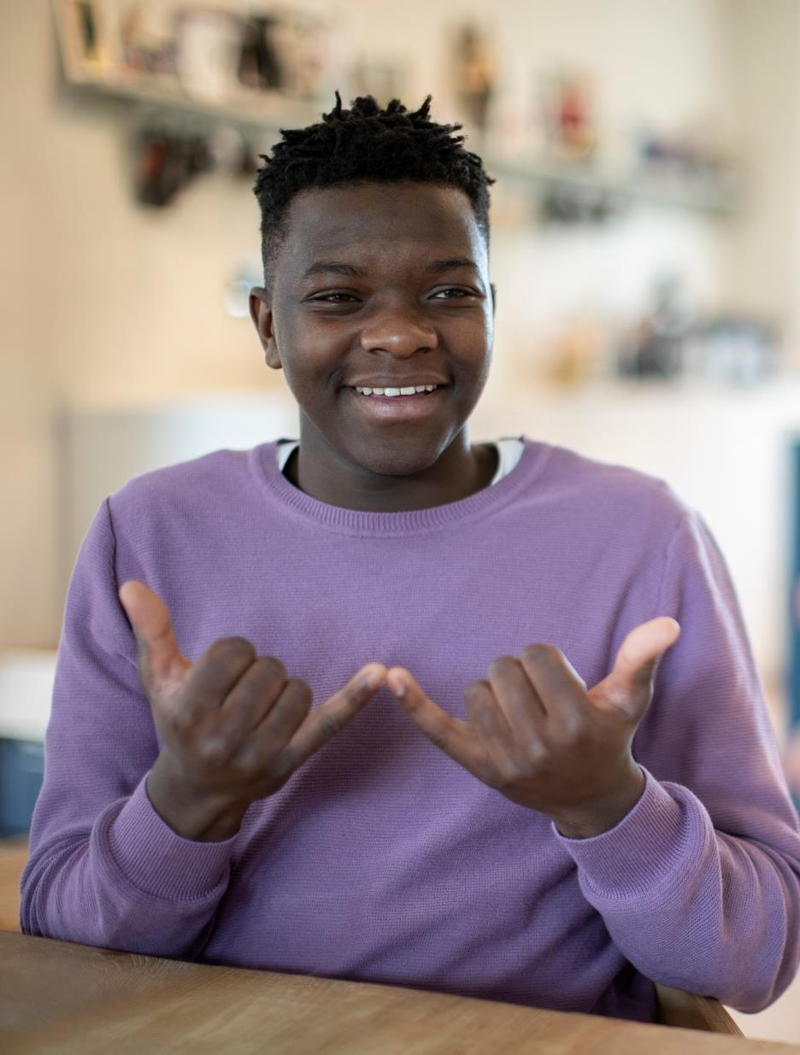

**Next Steps**

* Contact us to have an informal chat about the role
* Send your cover letter and CV to us
* We will interview all suitable candidates
* We will let you know the outcome within a week

We want to see the best of you at every stage of the process. Tell us about any adjustments you need to give you the best experience of this process and to remove barriers at every stage.

**Other Information**

We acknowledge that people from certain backgrounds are under-represented in our sector, and we’re committed to doing what we can to correct this. We are particularly keen to receive applications from Disabled people; Black, Asian and minority ethnic people; people who identify as being LGBTQIA2S+; and people who identify as working class now or in the past.

**GDPR personal data notice:**

As part of any recruitment process, DR UK collects and processes personal data relating to job applicants. In order to carry out the recruitment process we will share the personal data received from you in your application with the shortlisting and interview panel. Access will be restricted to those involved in the recruitment process.