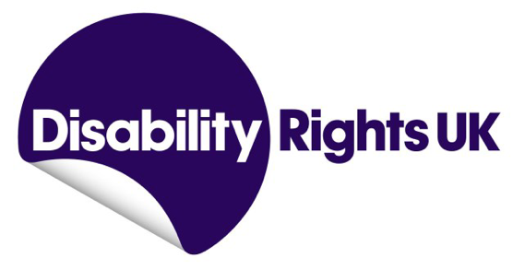

**Election of Trustees**

**Each year we reach over 1 million people with information developed by and for Disabled people**

Our free factsheets attracted over 600,000 downloads and over 90% of users said they were useful to their purposes.

We had tens of thousands of contacts with individuals through events and our independent living advice line, student and members helpline and information line.

In the year, we began work on a DPO hub that will be on our website. The hub will launch in the coming months with resources for DPOs.

Working with Disabled people and DPOs, we launched the Disabled People’s Manifesto. It is a robust set of demands from our community for the next UK Government. Look at the dedicated website: [DPO Forum Manifesto](https://www.disabledpeoplesmanifesto.com/).

**We are Disabled people leading change working for equal inclusive socity for all**

Disability Rights UK is the leading charity of its kind in the UK. We are run by and for people with lived experience of disability or health conditions.

We are:

* Committed to The Social Model of Disability.
* Led by people with lived experience of disability or long-term health conditions. 85% of our trustees have personal experience – our constitution ensures this will never fall below 75%.
* A member-led charity, with Disabled People and Organisations that are led by Disabled people having the controlling vote.
* Committed to working with and for people with all types of impairment and health conditions.

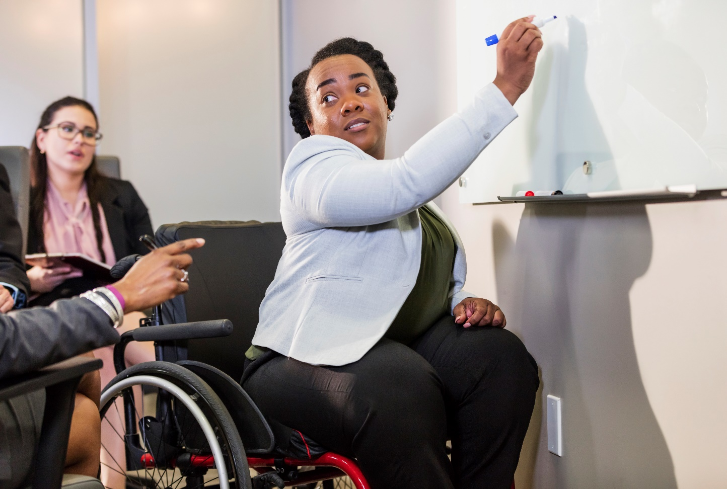

**Influencing policy and practice on the basis of lived experience and good practice led by Disabled people**

Disabled people continue to experience a perfect storm of inequality. For many, COVID is not over; access to social care, health and education services are strained, all the while enduring the spiralling cost of living. These burdens do not fall equally across society. Solutions remain under-resourced and underfunded. Our policy team have been working with Disabled Peoples’ Organisations (DPO) to respond to the growing challenges we face. We work to challenge and influence Government decisions, policies and legislation and have developed the Disabled Peoples’ Manifesto with a set of transformative asks of the next UK Government.

We provide the Secretariat to the All Party Parliamentary Disability Group (APPDG), bringing Disabled people’s voices into Parliament.

Our engagement work with DPOs has not only strengthened our links to local and regional organisations, but also amplified the collective voice of Disabled people. Our CEO and Head of Policy lead the monthly “Our Voices” meetings, a platform where the 25 CEOs of DPOs, collectively covering the whole of England, come together to advocate for the rights and needs of Disabled people.

We increased our twitter following to over 72,000. To engage with younger Disabled people we launched our TikTok channel which features guest Disabled influencers as well as our own team. Readership of our e-newsletter increased and now reaches over 20,000 people fortnightly.

**Delivering projects, working with local Disabled People’s Organisations and others, to demonstrate new approaches to disabled people’s participation**

The tenth cohort of Disabled people are currently completing our Leadership Academy Programme (LAP). Overall, 70-80% achieved their career goals, with project work being implemented in the guidance and policies of employers and delegates gaining MBE’s for their contribution to the sector. The programme has been developed based on feedback from participants using a co-produced approach. In recent years we have offered bespoke leadership programmes which includes new content such as conflict resolution, grief and loss and the co-produced ‘Inclusive Leadership Charter’.

Get Yourself Active is our programme designed to test and scale approaches led by Disabled people to tackling inactivity. We are a Sport England system partner, delivering training for social care professionals in physical activity promotion and working with Disabled People’s Organisations to deliver physical activity opportunities at a local level, plus much more!

The fund aims to reduce the negative impacts of Covid-19 and address any widening inequalities in participation rates in sport and physical activity in underrepresented communities. From April 2021 to March 2022, we funded 52 projects helping more than 1000 Disabled people become more physically active.

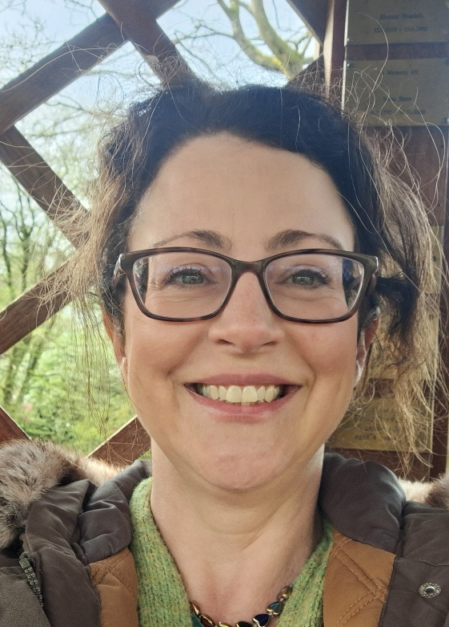

Trustees are ambassadors of DR UK, raising the charity's profile and reputation to a wide audience. They also contribute to achieving our vision and mission in communities, organisations, and at policy and government levels.

We look for trustees who share the values of DR UK and who can bring their own range of skills, experience and passion to the board. This includes bringing together a board of trustees who are representative of the broad and rich diversity of cultures and backgrounds that represent our communities in the UK.

If you would like to speak with me about the role, please include this request along with your application form, and we can arrange a time.

**Liz Leach-Murphy  
Chair – Board of Trustees**

Being a Trustee at Disability Rights UK provides an opportunity to contribute towards creating an inclusive society, where Disabled people have equal power, rights and equality of opportunity.

A founding principle of Disability Rights UK is to be a Disabled people led charity. To achieve this at least three quarters of the Trustees are disabled people. We aim for a diverse trustee board and therefore welcome applicants of all ages, backgrounds, disabilities and people with long-term health conditions.

The Board of Trustees contribute to the continued development and delivery of the strategy, in line with the Vision, Mission and Values of DR UK. The board oversees the delivery of the objectives and outcomes whilst meeting governance responsibilities. This includes meeting regulatory and statutory requirements, monitoring performance, approving annual budgets and risk management.

**We are Disabled people leading change.**

**To create an inclusive society where Disabled people have equal power, rights and equality of opportunity.**

**Message from our Chair**

We hope you will consider applying to become a Trustee.

Please read the following information and documents for information on our website:

* [Vision, Mission, Value Statements, Strategic Goals](https://www.disabilityrightsuk.org/about-us)
* [Articles Of Association, Annual Reports & Accounts](https://www.disabilityrightsuk.org/our-governance)

**Other information**

If you are elected, we will arrange an induction programme. This includes a full day induction on 29th November. Your first Board meeting will be on January 9th 2025.

If you are applying please make a note of those dates now. We will be deciding in September if the Board meeting in January will be in person or held remotely via a digital platform.

The role of Trustee is of vital importance to the running of Disability Rights UK and a commitment, but it is an opportunity to make a real difference to the lives of Disabled people and the barriers we experience as a community. Our shared lived experiences are at the centre of all that we do.

Thank you for your interest in the role of Trustee at Disability Rights UK.

We would particularly welcome applications from people who have expertise in one or more of the following:

* Experience of the grassroots disability rights movement
* Equality, Diversity & Inclusion
* Intersectionality
* Fundraising experience and skills
* Human Resources (HR)
* Safeguarding
* Policy and campaigning

Time commitment will vary but as a guide, you will be expected to:

* Attend four, Board meetings a year (held mid-week 11 a.m. to 3 p.m. These are held online and in person.
* Attend a Board “Away Day” once or twice a year, with DR UK staff team. This is usually held the day before the June Board meeting and could mean an overnight stay.
* Attend sub-committee meetings digitally – most trustees are members of either the Finance or the People, Equality and Governance Committee which each meet four times a year. These meetings are held online and are 2 hours long.
* Option to participate in working groups depending on skills, knowledge and availability.
* Attend an induction programme and other training as appropriate.
* Read Board meeting and other papers circulated to Trustees which arrive two weeks ahead of board meetings.

**What we are looking for**

**Timetable**

Send a completed application form to: **recruitment@disabilityrightsuk.org**

Or, post to:

**Disability Rights UK**

Plexal, 14 East Bay Lane, Here East

Queen Elizabeth Olympic Park

Stratford

London

E20 3BS

**The closing date is 5 pm on Friday 23rd August 2024**.

Applications received after this date will not be considered.

Interviews will be held digitally using Zoom on the 5th September 2024.

For an application pack or any queries, contact Ella Cobb by email: **recruitment@disabilityrightsuk.org** or call on 020 3687 0772

**Dates**

**Deadline for submitting applications:** 5 pm Friday 23rd August 2024.

**Successful applicants informed:**

Friday 30th August 2024.

**Interviews held via online platform:** Thursday 5th September 2024.

**Successful applicants informed:** 9th or 10th September 2024.

**Process**

Complete the application form. When completing your supporting statements, explain how you meet the core capabilities and how your skills, personal qualities and experience (paid work, volunteering and personal experience) will help you perform the role of Trustee.

The equality data collection section helps us to ensure that our processes are inclusive and to monitor engagement with Disability Rights UK across demographic groups. The information on this form will be treated confidentially and used for statistical purposes. It will not form part of your application. Candidates will then be shortlisted for interview. Candidates who are shortlisted can stand for election – the interview process decides whether or not the Board recommends individuals to the Disability Rights UK membership.

The application form asks for two referees. These should be individuals who are able to comment specifically on your suitability for the role of Trustee. If you are selected your referees will be contacted before the elections take place.

**Important information**

Some people are disqualified by law from acting as charity trustee e.g. anyone who has been convicted of an offence involving deception or dishonesty unless that conviction is spent and anyone who is an undischarged bankrupt. You need to be, or become, a member of Disability Rights UK to stand for election.

**How to apply**